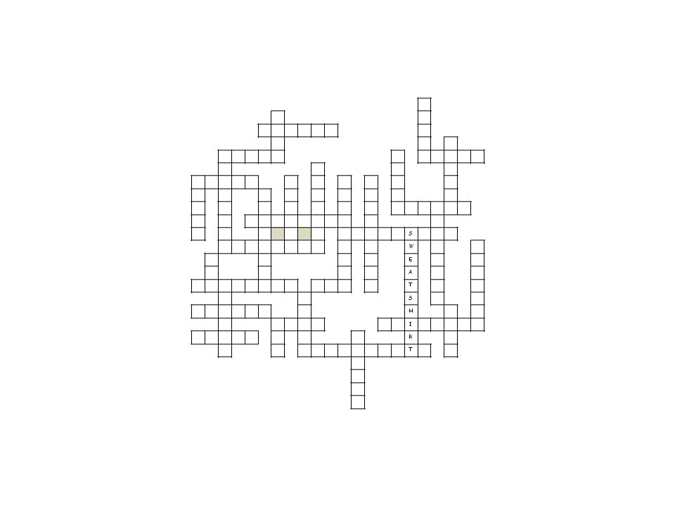

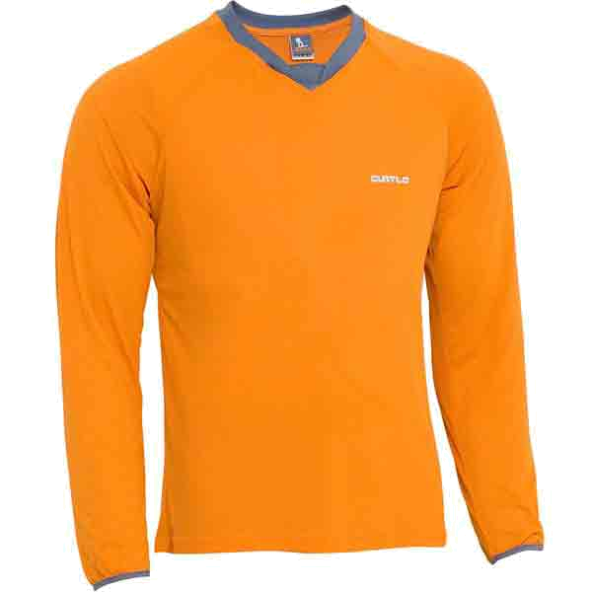


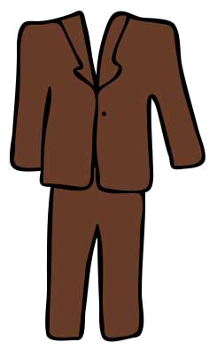
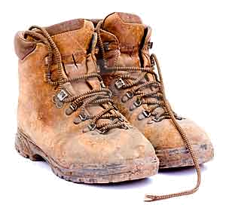
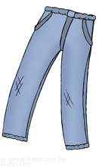
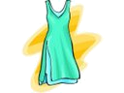
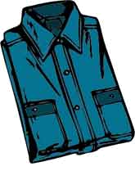
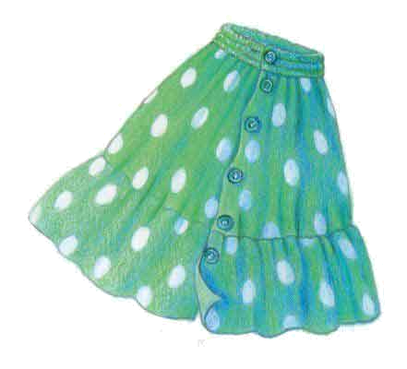
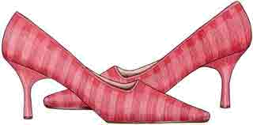
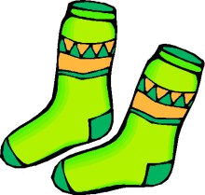
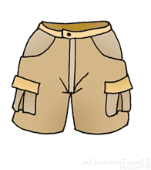
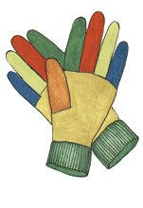
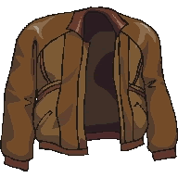
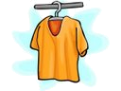
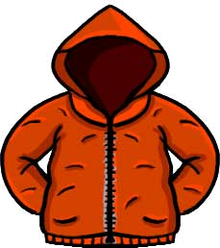

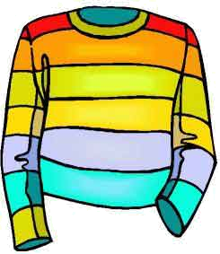
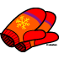
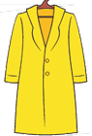
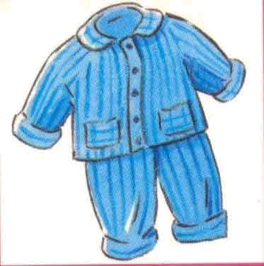
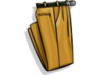
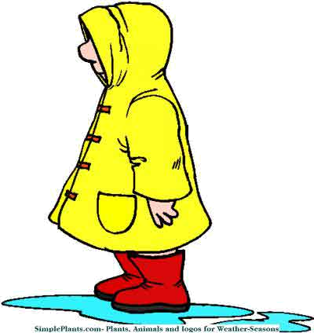
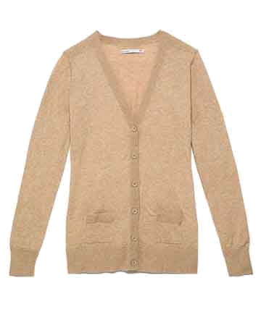
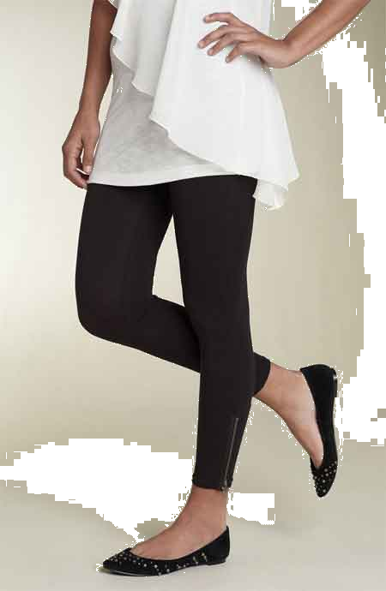
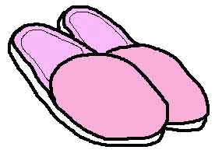
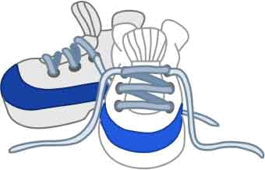

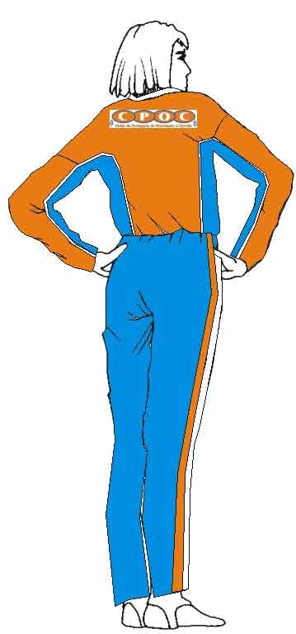
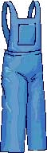
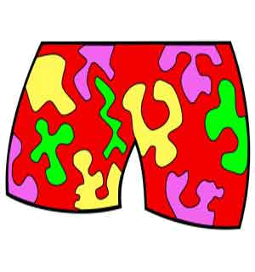
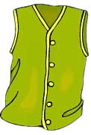
3 letters
___ hat
___ cap
___ tie
4 letters
___ coat
___ suit
___ belt
5 letters
___ boots
___ jeans
___ dress
___ shirt
___ skirt
___ shoes
___ scarf
___ socks
6 letters
___ shorts
___ gloves
___ jacket
___ t-shirt
___ anorak
___ jumper
___ blouse
7 letters
___ mittens
___ pyjamas
8 letters
___ trousers
___ raincoat
___ cardigan
___ leggings
___ slippers
___ trainers
___ swimsuit
9 letters
___ tracksuit
___ waistcoat
___ dungarees
10 letters
___ swim shorts
1 sweatshirt

Match the words to their pictures and solve the puzzle
1



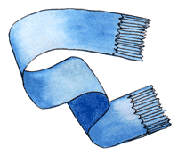

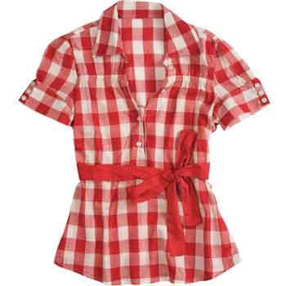

KEY:

 |  |  |  |  |  |  |  |  |  |  |  |  |  |  |  |  | S
 |  |  |  |  |  | S |  |  |  |  |  |  |  |  |  |  | O
 |  |  |  |  | J | U | M | P | E | R |  |  |  |  |  |  | C
 |  |  |  |  |  | I |  |  |  |  |  |  |  |  |  |  | K |  | J
 |  | S | H | I | R | T |  |  |  |  |  |  |  |  | B |  | S | C | A | R | F
 |  | W |  |  |  |  |  |  | M |  |  |  |  |  | O |  |  |  | C
S | K | I | R | T |  |  | B |  | I |  | W |  | D |  | O |  |  |  | K
H |  | M |  |  | C |  | L |  | T |  | A |  | U |  | T |  |  |  | E
O |  | S |  |  | A |  | O |  | T |  | I |  | N |  | S | H | O | R | T | S
E |  | U |  | T | R | O | U | S | E | R | S |  | G |  |  |  |  | A
S |  | I |  |  | D |  | S |  | N |  | T | R | A | C | K | S | U | I | T
 |  | T | R | A | I | N | E | R | S |  | C |  | R |  |  | W |  | N |  |  | P
 | T |  |  |  | G |  |  |  |  |  | O |  | E |  |  | E |  | C |  |  | Y
 | I |  |  |  | A |  |  |  |  |  | A |  | E |  |  | A |  | O |  |  | J
L | E | G | G | I | N | G | S |  | H | A | T |  | S |  |  | T |  | A |  |  | A
 |  | L |  |  |  |  |  | J |  |  |  |  |  |  |  | S |  | T |  |  | M
A | N | O | R | A | K |  |  | E |  |  |  |  |  |  |  | H |  |  | B |  | A
 |  | V |  |  |  | C | O | A | T |  |  |  |  | S | L | I | P | P | E | R | S
D | R | E | S | S |  | A |  | N |  |  |  | T |  |  |  | R |  |  | L
 |  | S |  |  |  | P |  | S | W | I | M | S | H | O | R | T | S |  | T
 |  |  |  |  |  |  |  |  |  |  |  | H
 |  |  |  |  |  |  |  |  |  |  |  | I
 |  |  |  |  |  |  |  |  |  |  |  | R
 |  |  |  |  |  |  |  |  |  |  |  | T

