**The Integration Situation**

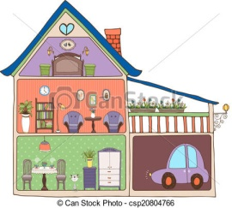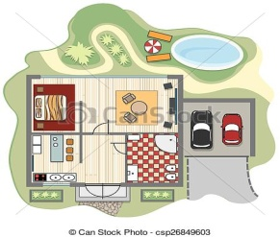My English friend Liz is asking me to tell her about the place where I live. So, I am going to send her **an e-mail** with a **detailed description of my house and my room.** I am also attaching a plan of my house.



**.......................................................**

**The Integration Situation**

My English friend Liz is asking me to tell her about the place where I live. So, I am going to send her **an e-mail** with a **detailed description of my house and my room.** I am also attaching a plan of my house.



**.......................................................**

**The Integration Situation**

My English friend Liz is asking me to tell her about the place where I live. So, I am going to send her **an e-mail** with a **detailed description of my house and my room.** I am also attaching a plan of my house.



**.......................................................**

**The Integration Situation**

My English friend Liz is asking me to tell her about the place where I live. So, I am going to send her **an e-mail** with a **detailed description of my house and my room.** I am also attaching a plan of my house.



**.......................................................**

**The Integration Situation**

My English friend Liz is asking me to tell her about the place where I live. So, I am going to send her **an e-mail** with a **detailed description of my house and my room.** I am also attaching a plan of my house.



**.......................................................**

**The Integration Situation**

My English friend Liz is asking me to tell her about the place where I live. So, I am going to send her **an e-mail** with a **detailed description of my house and my room.** I am also attaching a plan of my house.



**.......................................................**

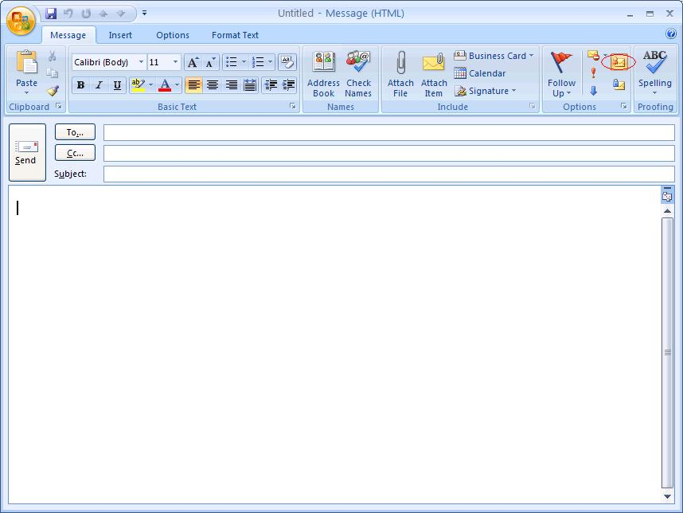

[Liz_clacksmith@fastmail.uk](mailto:Liz_clacksmith@fastmail.uk)

My house

Hello, Liz!

Last time, I promised to tell you about the place where I live. Well, I live .......................................

..................................................................................................................................................................................

..................................................................................................................................................................................

..................................................................................................................................................................................

..................................................................................................................................................................................

..................................................................................................................................................................................

..................................................................................................................................................................................

P.S. Find atached a detailed plan of my .............................................................................................

Kind regards,

.........................................



[Liz_clacksmith@fastmail.uk](mailto:Liz_clacksmith@fastmail.uk)

My house

Hello, Liz!

Last time, I promised to tell you about the place where I live. Well, I live .......................................

..................................................................................................................................................................................

..................................................................................................................................................................................

..................................................................................................................................................................................

..................................................................................................................................................................................

..................................................................................................................................................................................

..................................................................................................................................................................................

P.S. Find atached a detailed plan of my .............................................................................................

Kind regards,

.........................................