**Learning Situation to Install Resources:**

You are at the police station to report your **lost** sister/brother.

Help the police find her/him by **describing** her/his age, height, build, hair, eyes, nose and clothes.

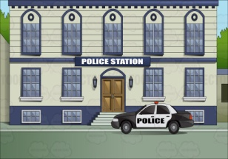 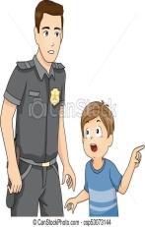    
..........................................................................................

**Learning Situation to Install Resources:**

You are at the police station to report your **lost** sister/brother.

Help the police find her/him by **describing** her/his age, height, build, hair, eyes, nose and clothes.

     
..........................................................................................

**Learning Situation to Install Resources:**

You are at the police station to report your **lost** sister/brother.

Help the police find her/him by **describing** her/his age, height, build, hair, eyes, nose and clothes.

     
..........................................................................................

**Learning Situation to Install Resources:**

You are at the police station to report your **lost** sister/brother.

Help the police find her/him by **describing** her/his age, height, build, hair, eyes, nose and clothes.

     
..........................................................................................

**Learning Situation to Install Resources:**

You are at the police station to report your **lost** sister/brother.

Help the police find her/him by **describing** her/his age, height, build, hair, eyes, nose and clothes.

     
..........................................................................................

**Learning Situation to Install Resources:**

You are at the police station to report your **lost** sister/brother.

Help the police find her/him by **describing** her/his age, height, build, hair, eyes, nose and clothes.

     
..........................................................................................

**Learning Situation to Install Resources:**

You are at the police station to report your **lost** sister/brother.

Help the police find her/him by **describing** her/his age, height, build, hair, eyes, nose and clothes.

     
..........................................................................................

**Learning Situation to Install Resources:**

You are at the police station to report your **lost** sister/brother.

Help the police find her/him by **describing** her/his age, height, build, hair, eyes, nose and clothes.

     
..........................................................................................